**CP Club 365 Days Challenge**

**Programming language – C++**

**Problem Statement**

<https://www.codechef.com/START76B/problems/NOTDIVISIBLE>

Git :- <https://github.com/Vedantbharad2603/CP_club_365_Days>

**Your Code**:

// 0x108Day of 0x365Days challenge

// VEDANT BHARAD

// 2-2-2023

#include <iostream>

using namespace std;

int main() {

    int t;

    cin>>t;

    while(t--){

        int n;cin>>n;

        for(int i=0;i<n;i++){

            if(i%2==0){

                cout<<0<<" ";

            }

            else{

                cout<<1<<" ";

            }

        }

        cout<<endl;

    }

    return 0;

}

**Output (Screen Shot)**:

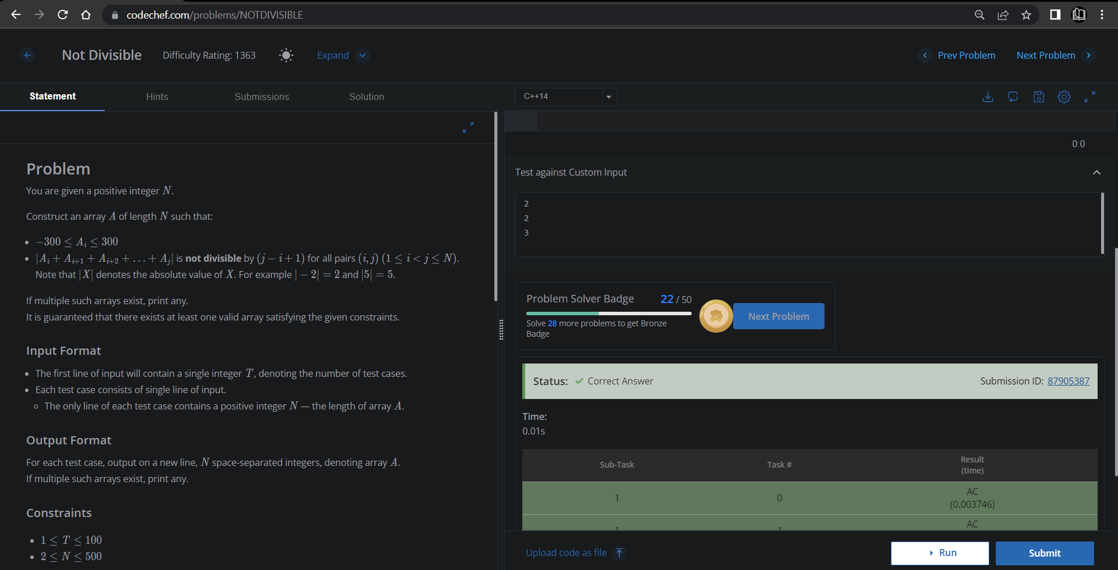

**Understanding about problem:**

* In this task I need to print n number (0 to n) first start from 0 to N if that number is odd then print 1 else print 0.

Note: If you can't understand the problem, feel free to contact us and we'll help you. Please don't copy and paste from anywhere.

ALL THE BEST

Team CP Club